Written Representation of Bishopton Villages Action Group (BVAG)

Application by RWE Renewables UK Solar and Storage Limited
Proposed Development Consent for the Byers Gill Solar Project.

PINS ref: EN010139

29th August 2024

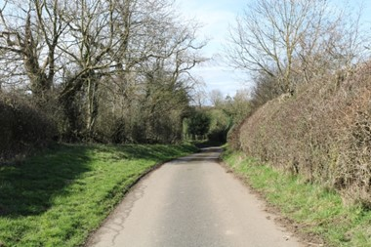
Figure 1 - View in Bishopton Landscapes Copyright: Carly Tinkler

Prepared by: Andrew Anderson BA (Hons) DipTP MSc MRTPI FRGS

Contents

Executive Summary
- Introduction and BVAG
- The Proposal
- Planning Policy
- BVAG Issues Framework with focus on Heritage
- Conclusion

List of Appendices
Appendix A – Issues Framework Table

Executive Summary

To Follow

Introduction

All Interested Parties were invited to submit Written Representations (WR) by the Examining Authority. This WR is submitted on behalf of Bishopton Villages Action Group (BVAG) for Deadline 2, Thursday 29 August 2024 as per the Examination Timetable.

This is the WR of BVAG and does not necessarily express the views of the local Parish Councils or Meetings, although many of the opinions are shared by these and individuals within the affected community. BVAG includes the villages of Bishopton, Great Stainton, Little Stainton, Brafferton, Whitton, Stillington, Sadberge, Carlton, and Redmarshall.

Bishopton Villages Action Group (BVAG) a registered Interested Party (IP Reference Number 200048675) to the Examining Authority. The WR develops and builds on previous submissions made by BVAG to the Ex. These are as follows:-

BVAG Adequacy of Consultation Representation (February 2024) appended to Darlington Borough Council’s response to the Secretary of State (SoS) regarding the Applicant’s Adequacy of Consultation.

BVAG Relevant Representations (RR-548) submitted 15th May 2024 and registration as an Interested Party (IP Reference Number 200048675) and summary of RR by Deadline 1 (13th August).

BVAG Response to ExA Rule 6 letter - Written submissions on the Examination Procedure and Timetable (July 2024) including suggested locations for Site Inspections Accompanied and/or Unaccompanied and attaching a map and table of other solar schemes consented in the near area.

BVAG attendance at Preliminary Hearing on 23rd July 2024 and Open Floor Hearing (OFH) 1 on 24th July 2024.

RWE/BVAG Statement of Common Ground and exchange of drafts for submission for Deadline 1 (13th August 2024).

The key to understanding the proposal is to understand its scale. The Byers Gill Solar Energy proposal covers approximately 490 hectares (ha) and is expected to generate up to 180MW of electricity. As the DBC point out “The area is approximately equivalent to the total area of land covered by the eight solar farms with consent and/or under construction in the 3km Study Area i.e. the cumulative solar projects.“ (Para 7.3 DBC LVA) BVAG fear it could potentially expand even further.

With regard to the Byers Gill Solar Energy scheme BVAG confirms its Objection to the proposals and on the basis of the information provided with the application, due to the widespread significant adverse impacts on people, land, flora and fauna, and the wider environment, and respectfully requests that the Examining Authority recommend that the DCO is refused.

My Qualifications

I have been instructed by the Bishopton Villages Action Group (BVAG) since the pre-application stage to review and assess the proposed Byers Gill Solar Energy development.

I am a Chartered Town Planner with a BA (Hons) degree in Town Planning, a Post Graduate Diploma in Town Planning, and a Master of Science Degree (MSc.) in Environmental Impact Assessment and Management. I have been a Member of the Royal Town Planning Institute since 1992. I was elected as a Fellow of the Royal Geographical Society in 1996.

I have practised as a town planner for over 30 years in the UK and abroad, working for developers, national Governments (including UK), the United Nations, the European Union, NGO’s, the British Embassy and local planning authorities. I have considerable experience on a wide range of development proposals, including residential, commercial, farming and heritage conservation, culture and tourism, and solar energy projects.

I have considerable experience around issues of land use, climate change and sustainable development. I am an independent consultant and a retained Assessor for the King’s Award for Enterprise (Sustainable Development). I am familiar with solar energy projects and the wider climate change and sustainability context which drives renewable energy policies.

Structure of the Written Representation

The WR broadly follows the issues-based framework of the BVAG Relevant Representation (RR-548) as submitted to the Examining Authority (ExA) in May 2024. Issues have been added where these have arisen since the previous submission. In order to assist the ExA the BVAG Issues Framework will refer where relevant to questions raised in the ExQ1. Broadly, the RR raised the inadequacy of information across many areas in the DCO application and BVAG welcomes that fact that the ExQ1 addresses many of the same questions and the gaps identified by BVAG and the wider community across the villages affected by the proposals.

It is therefore envisaged that in addition to the WR provided here, that further comments will be made by BVAG in ‘Comments on responses to ExQ1’ Deadline 3 (19th September 2024).

Preliminary and Open Hearings

BVAG would like to take this opportunity to record their thanks for the way that the Preliminary Hearing and Open Hearing were conducted, and that the Inspectors encouraged the community to raise topics and allowed discussion. The Hearings provided a voice to the community which it is felt has been absent until now.

The ExA has concluded on advice from the local authorities, that the pre-application statutory consultation process was adequately conducted. From the community perspective there was a significant gap between statutory consultation and meaningful dialogue. The SoCG process which has arisen from the Preliminary Hearing is therefore welcomed. BVAG intend to enter into discussions and have since accepted an invitation to meet with RWE’s agents, Arup, to discuss the proposals. The meeting is due to take place on the 17th September 2024.

BVAG hoped that there remains scope within the process for real dialogue and a review of the proposed development both in terms of its scale, designed and layout. Where BVAG has suggestions for change it is hoped the Examination allows for these to assessed.

BVAG has made a formal Request as an IP to be heard at a future Open Floor Hearing (OFH) in accordance with Deadline 1. The topics raised will depend on progress at that time.

Statement of Common Ground (SoCG)

Following the Preliminary Hearing BVAG received a draft SoCG from the applicant. This was consulted on within the community and returned with comments to RWE’s agents (Arup) on the Friday 9th August 2024 to allow time for them to submit the next Draft SoCG to the ExA for Deadline 1 (August 13th 2024).

There remain substantial areas of disagreement, and several areas under discussion. BVAG remain committed to the process of dialogue, and sharing opinions and perspectives with the applicant.

Local Impact Report

A Local Impact Report was submitted by the local planning authorities at Deadline 1. This Written Representation draws upon the conclusions reached in the DBC Local Impact Report (REP1-023) and while it focuses on the impacts of the proposed scheme in the district of Darlington Borough Council, it also acknowledges where impacts will be felt more widely, including cumulative impacts. It is noted that comments on the LIRs are requested by the ExA for Deadline 2. This WR should be considered as BVAG initial comments on the LIR for Deadline 2.

BVAG has reviewed the Local Impact Report submitted by Darlington Borough Council (DBC) and broadly welcome its approach and findings. There are issues which BVAG view differently but we are in broad agreement with DBC’s LIR. Area of difference are outlined in Table 1. below.

As pointed out in BVAG’s earlier RR, the community very much rely on the Council - and other statutory undertakers and expert groups - to provide an independent assessment of the impacts of such a proposal. These public bodies have the resources to undertake independent assessments. They also have a duty to reflect the experience of and support the local community. Ideally, BVAG and the community would have had an opportunity to input into, and shape the LIR rather than respond to a final Report.

BVAG support the findings of DBC’s ‘Landscape and Visual Amenity’ (LVA) Report (REP1-021) which forms part of the LIR identifies many of the adverse impacts resulting from the scale of the proposal, and the impact of cumulative development. The LR also notes the inadequacy of the mitigation proposed, and the lack of detail in design and equipment.

The LIR LVA also recognises and demonstrates the adverse impacts of the proposal in terms of the setting of historic assets such as the Bishopton Conservation Area and the Bishopton 11th century Motte and Bailey. The photomontages presented demonstrate the destruction of views and landscape character and the close proximity of proposed Panel Areas to homes and villages.

Such is the importance of the impact on landscape and the area, that Landscape and Visual Amenity is also the subject of a BVAG specialist report accompanying BVAG WR (Landscape and Visual Review - Carly Tinkler BA CMLI FRSA MIALE).

The table below sets out the areas of agreement within the DBC LIR and the BVAG positions across key issues.

BVAG WR also addresses gaps in the proposal description and the application documents:-

MW generation capacity

public benefits of the proposal

temp vs permanent beyond 40 years

financial viability

sustainable development goals and life cycle analysis

Table 1. Alignment of Darlington Council’s Local Impact Report and BVAG positions.
DBC LIR position | BVAG position
DBC has identified a number of potential negative impacts, which can be summarised as follows:  The scale and significance of the impact on the landscape and visual amenity of the area, both in isolation and cumulatively  The loss of agricultural land, including a small proportion of BMV, both in isolation and cumulatively  The potential for the development to impact upon the community in terms of glint and glare, and noise and vibration, although with the submission of further information/clarification such impacts could potentially be considered neutral  Impact on the local highway network principally during the construction period and also during the operational period (glint and glare mitigation), although with the submission of further information/clarification such impacts could potentially be considered neutral | BVAG agrees entirely with the negative impacts as identified by DBC in the LIR :-  - Landscape and Visual Amenity harm  - Loss of farming land  - Cumulative impacts  BVAG agrees that the glint and glare has not been fully considered and that the key gaps are  - Methodology for assessment.  - Reliance entirely on dwellings, and not on walkers, public spaces, horses riders and equine business, tourists, drivers etc.  - Insufficient information on mitigation measures and timescale for hedge growth and maintenance over 40 years.  BVAG disagrees that the highway network impacts can be made neutral. Local knowledge and experience provides important information.  BVAG Issues Framework identifies information required and gaps in the Highways proposals especially with Visibility Splays and Access.
DBC have concluded that the following neutral impacts have been identified, subject to appropriate mitigation where necessary, and are listed below:  - Air Quality  - Land Contamination  - Heritage Assets  - Protected species (subject to further assessment of water voles) | BVAG strongly disagrees with DBC that these issues can be neutral or dealt with by the mitigation. In particular BVAG considers there is residual and significant harm to  - Built Heritage Assets  - Archaeological Assets  - Wildlife and Ecology  BVAG relies on the relevant authorities to assess air quality and land contamination issues.
Positive impacts are identified in terms of biodiversity net gain. | BVAG disagrees with DBC conclusions. Reasons set out in the WR Issues Framework below.
DBC consider that further information is required in respect of the following subject areas before the Council can form a view on the impacts arising from the proposed development, and would welcome the opportunity for further discussions on these matters during the examination period:  - Flooding and drainage (further clarity on sequential test)  - Public Rights of Way | BVAG agrees that further information is required to fully assess  - Flooding  - Public Rights of Way  Issues of flooding around construction and operations are set out in the Issues Framework and BVAG’s own LVA.

The Proposal

Byers Gill Solar Energy Farm comprises the construction, operation and decommissioning of a solar energy installation described as capable of generating ‘over 50 megawatts’ of electricity. The proposal is located across the administrative areas of Darlington Borough Council, Stockton on Tees and Durham County Council.

The application for the Byers Gill Solar DCO is submitted as 171 separate documents (APP_001 to APP-171). These are then supplemented by additional submissions. It is my opinion that the volume of documentation provides a challenge to communities to understand and react to such proposals, especially within the resources and timescales allowed. The Examination Authority´s willingness to listen to the community at the Preliminary and first Open Hearing, and the range of questions put to the applicant in ExQ1 are therefore welcomed by BVAG.

The proposals are spread across 6 panel areas (Labelled A to F) over 490 hectares and include a battery energy storage system, a new on-site substation and up to 31 kilometres of underground cabling to connect panel areas to the on-site substation, and to then connect the on-site substation to the Norton substation in Stockton. In addition, a range of supporting infrastructure is proposed. The principal components of which are the following:-

PV modules.

Mounting structures.

Invertors.

Transformers.

Switchgear.

Onsite substation and ancillary buildings.

Low voltage distribution cables.

Grid connection cables.

Fencing, security and ancillary infrastructure.

Access tracks.

The proposal affects land across neighbouring sites between Darlington, Newton Aycliffe and Stockton-on-Tees, in and around the villages of Bishopton, Great Stainton, Little Stainton, Brafferton, Whitton, Stillington, Sadberge, Carlton, and Redmarshall.

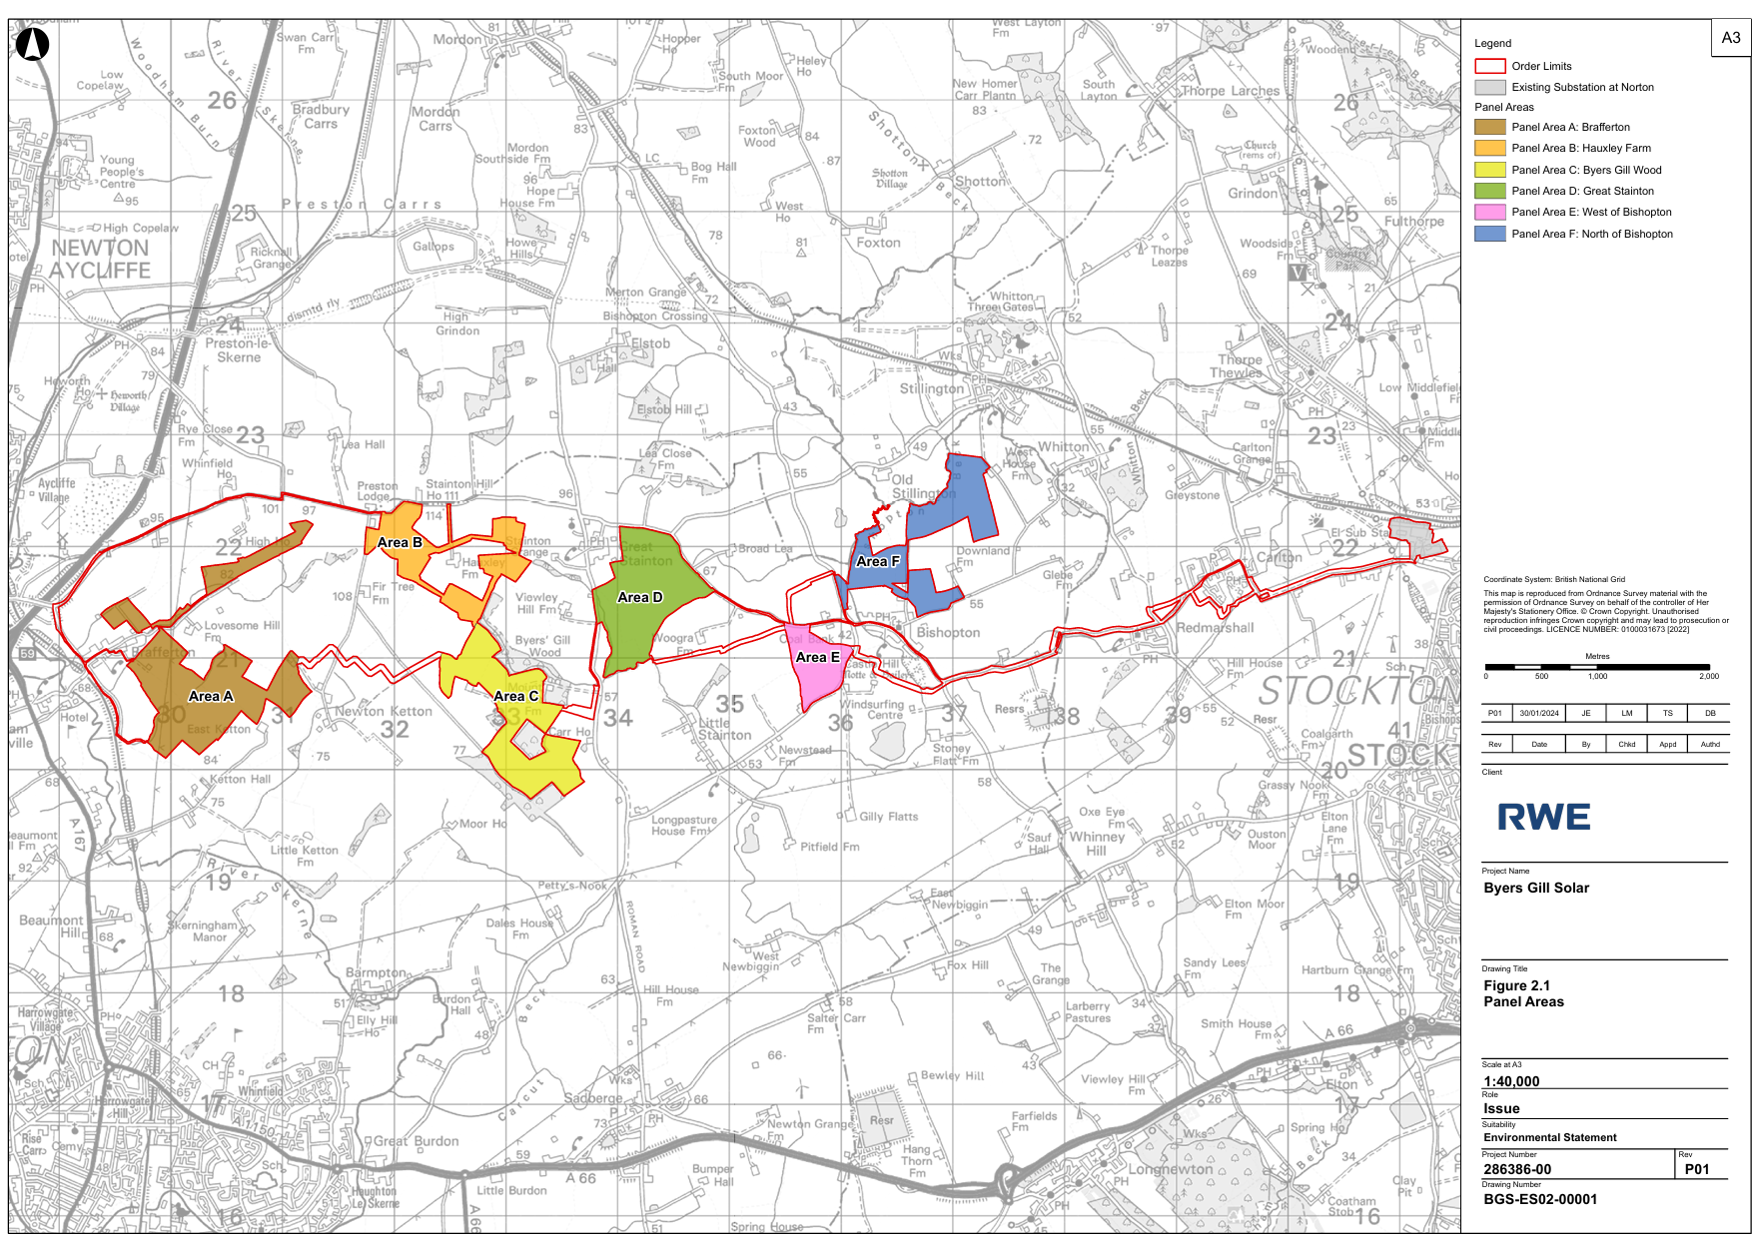
Figure 2 - Proposed Byers Gill Solar. Extract from RWE Document 6.3.2.1 (Fig 2.1).

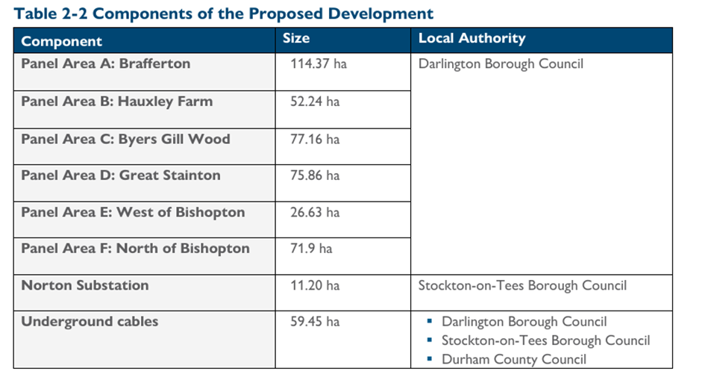
Figure 3 - Extract from RWE Document 6.2.2 'Proposed Development' Ch.2 Environmental Statement.

The description in the Application Form itself does not limit the development to a temporary operational period. The Planning Statement describes “ The temporary, 40-year operational period of the Proposed Development is secured via the DCO (Document Reference 3.1)”.

The Draft DCO sets out in Schedule 2 Part 1 Requirement 5 that decommissioning must commence ‘no later than 40 years following the date of final commissioning of the first phase of numbered work’. Requirement 2 (4) also says “Nothing shall prevent the undertaker and the relevant planning authority agreeing from time to time to amend the written scheme setting out the proposed phases of construction.” BVAG would request clarity on potential timelines which the Draft DCO would allow from consent to decommissioning.

The Design Approach

BVAG consider that DBC’s LIR has rightly identified fundamental flaws in regard to the proposal. Because the scheme is led by gird connection availability and identifying willing landowners, the design and mitigation are secondary. In other words, this is not the best location for a solar scheme of this scale, but a solar scheme that has been designed around the only available grid connections and willing landowners.

DBC LIR concerns are set out in full in the LIR and BVAG would like to reiterate here and draw to the attention of the ExA :-

DBC LIR Para 5.6.7

“It is unclear from the Design Approach Document, the ES or any other supporting document, the rationale behind the following key design principles which characterise the scheme layout for Byers Gill Solar.

a) The clustering of solar panel areas around rural settlements and their landscape setting.

b) The clustering of solar panel areas along the most commonly used country road in the Study Area connecting local villages.

c) The dispersed nature of the solar panels covering a wide geographic area (25km2).

d) The limited potential for expansion of Panel Areas B and C on land regarded as less sensitive (outside the village settings) and with relatively few environmental constraints.

e) The introduction of solar panels in open countryside on the edge of Bishopton with high visual amenity value due to proximity (and visual connectivity) to important walking routes, residential and community properties and recreation facilities.”

DBC assessment concludes this is a ‘key weakness’ in the presentation of design principles and makes it difficult to assess mitigation and enhancement measures in terms of ecological infrastructure and wildlife.

RWE – the applicant

The Application introduces RWE in Document ‘1.2 Introduction to the Application’ (APP-002) as follows:-

“RWE Renewables UK Solar and Storage Limited…is a major solar energy developer, and has secured planning permission for over 1GW of solar projects since 2012. The Applicant is committed to delivering large-scale solar farms with co-located battery storage, and a minimum of 50% biodiversity net gain on every project”

The nature and background of the applicant is clearly of relevance to the local community, given the nature and scale, permanence and character of the proposal which is to be literally surrounding their homes and villages for miles around.

The background of the potential ‘new neighbour’ is relevant. The applicant is a part of the RWE Group, (‘ Rheinisch-Westfälische Elektrizitätswerk’) a German-based company Headquartered in Essen, North Rhine-Westphalia. The company was founded in 1898 and was traditionally based around coal mining for which that part of Germany is well known. Over time, and surviving (even thriving) in the turbulent history of 20th century Germany, Forbes give a description of RWE today as follows:-

“It (RWE) operates through the following segments: Lignite & Nuclear, European Power, Supply & Trading, Operations Acquired from E.ON and innogy. The Lignite & Nuclear segment covers electricity generation in Germany using lignite and nuclear power. The European Power segment comprises the electricity generation business in Germany, the U.K., the Netherlands, and Belgium using gas and hard coal power plants.”

The applicant and proposal at Byers Gill would therefore be a component of a global energy portfolio, owned and controlled by a foreign company, which holds and operates a range of energy installations both renewable and non-renewable worldwide. Income before tax according to the company website is 3,291 million Euro which is relevant here in terms of proportionate community benefits and project viability. RWE’s key shareholders are the Qatar Government (Sovereign Wealth Fund) and Black Rock Investment. The diagram below illustrates the global and foreign ownership.
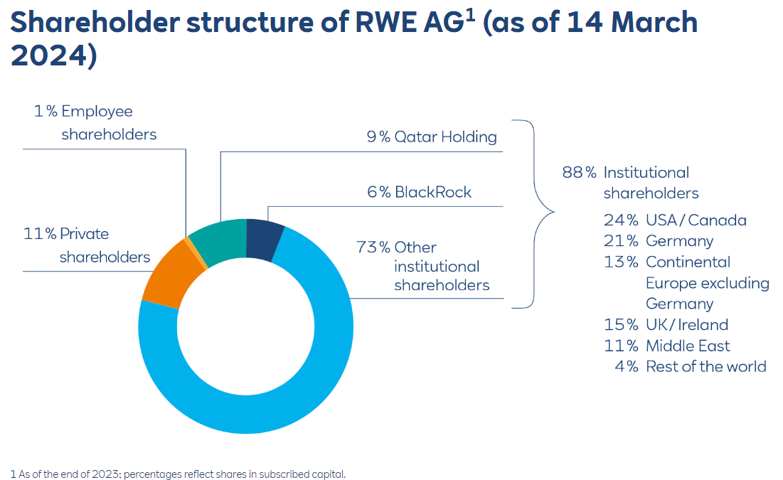
Figure 4 - Shareholding RWE Source: RWE
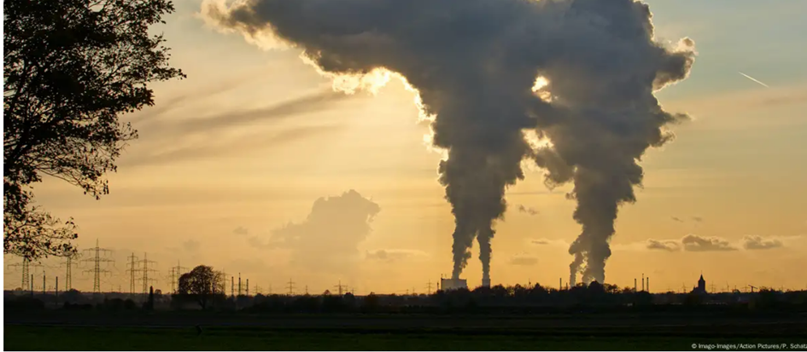
Figure 5 - RWE is traditionally associated with coal and lignite mining and continues this globally.

RWE is reportedly one of the largest fossil fuel producers in Europe. Greenpeace in RWE’s home country of Germany have published research which confirms the company as one of Europe’s largest polluters. It is not within the scope of the WR to investigate such reports but BVAG would be grateful for further information on the applicants activities worldwide.

RWE has a duty to its shareholders, and BVAG are concerned to understand how these legitimate interests are balanced with the interests in local communities. For example, RWE has gained considerable press attention around the expansion of open cast coal mines in Germany. As one reporter wrote

“LÜTZERATH, WHICH WAS ONCE home to about 100 people, sits in the path of a massive, expanding open-pit coal mine — Garzweiler II. The mine lies west of a six-lane autobahn from the original Garzweiler mine. Together, the two mines have already eaten up 32 square kilometers of land, as well as 20 villages along with their centuries-old farmhouses, generational homes, churches, and graveyards. Among the first to go was the village of Garzweiler, after which the mines are named. The two Garzweiler pits are run by the multinational energy group RWE Power.”

The report It continues,

“On the company’s website, one can see photos of lush green forests and wind farms in the sea along with bold claims about how the company “is shaping the sustainable future of energy supply.” But here in the Rhine region of West Germany, the company has one main interest: brown coal, or lignite.” (Source: On the Edge (earthisland.org))
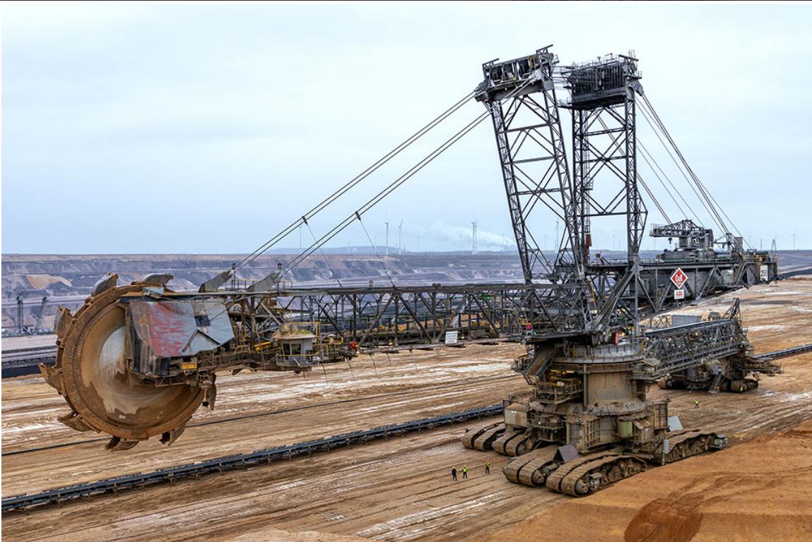
Figure 6 RWE in Germany - part of a portfolio of energy operations globally.

It is beyond the scope of this WR and BVAG’s resources to be fully updated on the current situation in RWE’S activities globally, but it is of concern as to how they would operate within the communities and villages of the Order Limit around Byers Gill and Darlington.

BVAG understands that like many energy companies, there is a market and regulatory need to shift from traditional fossil fuels to renewable energy. As part of a widening of the energy portfolio and an expansion into the UK, RWE have acquired JBM in the UK and it is understood to have taken over JBM solar energy portfolio, which includes Byers Gill Solar proposal. In doing so it has inherited certain commitments and a project trajectory. The long term commitment of REW is therefore a legitimate concern to local residents and the community,, as well as to operational and de-commissioning issues.

The Draft DCO Part 2.6 ‘Consent to transfer benefit of Order’ (APP-012) provides for the Byers Gill Energy Installation to be transferred should RWE wish to do so in the future. This Article is required in order that the undertaker has commercial flexibility to transfer the benefit of the Order to a third party, subject to certain provisions. BVAG are concerned therefore that this provision allows for the further transfer of the scheme to unknown parties and would ask the ExA to consider if this Draft DCO should or can be, amended to restrict the consent to RWE should consent be granted.

The applicant has introduced RWE company`s green credentials and therefore made the issue relevant to the Examination. However, it is clear that RWE has a financial interest beyond solar and biodiversity gain as stated in the application. Sky News reported in September 2021 recently that

“Fossil fuel firms sue governments across the world for £13bn as climate policies threaten profits”.

According to ‘Global Justice Now’, which has collated publicly available information, five of the largest lawsuits under way are being brought by TCEnergy, RWE, Uniper, Rockhopper and Ascent Resources. BVAG cannot comment on what it assumes must be legitimate financial decisions. It is beyond the scope of this WR to investigate the current situation with these reports.

The background demonstrates that RWE is a foreign-owned, global energy business and it is not solely a UK company in pursuit of solar and renewable energy. Intentions and motives matter. Important decisions ultimately lie overseas and this creates challenges for RWE in understanding and responding to the needs of communities in the Darlington and Stockton areas. When operational it would be important for the community to have an ‘open door’ and genuine dialogue with the operators of a such a massive power station, sprawling across their villages and surrounding fields. Such dialogue can suffer when control of the facilities is overseas nor open and transparent.

The Byers Gill proposal, which started under JBM, has been passed onto a foreign company, RWE, and is being delivered for shareholders as part of a global energy portfolio. The wider UK public benefits need to be balanced with the overseas private benefits.

Generating Capacity

BVAG would like to raise concerns that the generational capacity is not clear, and that application should provide clarity on a maximum MW capacity.

The application seeks consent for a solar energy installation “capable of generating over 50 megawatts of electricity” (Ref: Application Form APP-003 and 004) but does not clarify what the maximum generating capacity it is designed to achieve.

In RWE Document 6.1.1 ‘Environmental Statement Non-Technical Summary’ the applicant states

“A connection agreement has been secured with NPG for the generation of 180 MW of electricity” (Para 3.1.5)

In RWE Document 7.1 ‘Planning Statement’ it states,

“Byers Gill Solar would make a positive impact on the UK’s energy market, by providing an expected 180 MW of low-cost, clean and renewable electricity to UK customers” (Para 3.2.38).

The application form and Draft DCO are seeking consent to ‘exceed 50MW’ without any maximum cap. The Planning Statement and ES Non-Technical Summary refer only to connection agreements and expected output, again without a maximum cap. BVAG are concerned this could provide for increases in MW generation over time, and consequences for infrastructure, design and layout and scale of proposal, and viability and therefore potential incentives to extend operations beyond 40 years.

The need for land, and the wider benefits of the proposal are related to the MW generation, and the estimated 70,000 homes which the applicant has said will be provided with electricity.

The relevant NPS EN-3 Paragraph 2.6.1 ‘Flexibility in the project details’ states that,
“Where details are still to be finalised applicants should explain in the application which elements of the proposal have yet to be finalised, and the reason why this is the case.”

NPS EN-3 Para 2.6.2 continues

“Where flexibility is sought in the consent as a result, applicants should, to the best of their knowledge, assess the likely worst-case environmental, social and economic effects of the proposed development to ensure that the impacts of the project as it may be constructed have been properly assessed”.

BVAG seek assurances whether a maximum MW generation cap would allow for more clarity over the design and layout, and how it relates to future plans and potential extensions beyond 40 years. The ExQ1 is therefore welcomed in this regard and BVAG looks forward to the applicant’s response to ExQ1 ‘PPD.1.1 to PPD.1.14.

BVAG’s view is that the uncertainty, and a lack of clarity about the current proposal provides potential for further expansion both in intensification of use, further land or extensions of time beyond 40 years. Greater transparency would assist in community engagement.

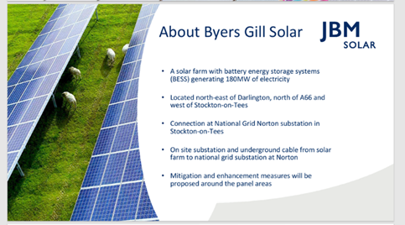
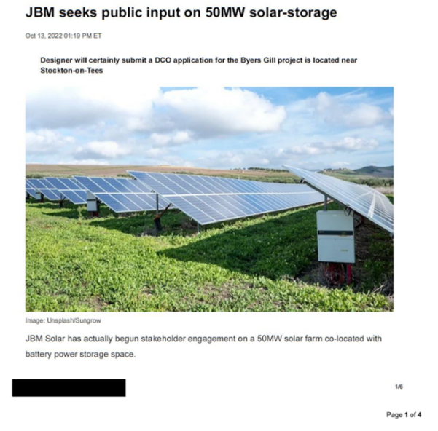
Figure 7- Early publicity for 50 MW at Byers Gill

Figure 8 - Publicity for 180MW at Byers Gill

Public Consultation and Undermining public confidence

The RWE website referred to in the RR continues to present the byers Gill proposal as being part of a portfolio with all planning consents in place and states it will become operational in 2026. This in our opinion continues to undermine the planning consent process. Any reasonable reader would assume from the RWE website that the Byers Gill Solar scheme is consented and was due to become operation in 2026.

This creates an impression that the recommendation of the Examination Authority and the subsequent Secretary of State’s decision is a foregone conclusion. It undermines the process and the undermines the confidence of the community that the decision will be based upon the evidence of all participants. It feeds into the narrative about RWE and their community relationships globally.

Since MW generation is important to the design and layout around panel type, size, placement, site design, and orientation BVAG would suggest the ExA recommend placing a limit on the MW project size through any consent on the Draft DCO.

Further, because of the rapidly improving energy density of solar panels, land area required per MW of generation capacity is constantly shrinking and could potentially further reduce even over the length of the planning approval process. The applicant should therefore justify the land area of panels proposed in relation to the intended MW export.

Upgrades to Norton Sub-station

RWE document 6.2.2 ‘Environmental Statement Chapter 2 referring to the need to create the connection to Norton Substation (’The Proposed Development’) states that

“It is expected that NPG would carry out these works to connect the Proposed Development. “
It continues that in addition to the upgrades needed at Norton Sub-station to enable the Byers Gills connection, that,
“NGET are proposing further reinforcement works at Norton Substation comprising of 400kV/132 kV Super Grid Transformer and associated equipment. These works are part of a wider reinforcement of the NGET network and are not directly related to Byers Gill Solar. For this reason, they do not form part of the Proposed Development. “ (Paras 2.3.36 and 2.3.37).

BVAG would ask the ExA to request that the applicant clarifies if the future works to the Norton Sub-station are needed for the current proposal, and if the additional works provide for expansion beyond the current 180MW connection agreement. BVAG would like to ask if the applicant has explored the potential for further installations within the same DCO area or had discussions with landowners or others, to extend the proposed Panel Areas, and also to extend the operational period of 40 years.

ExQ1 seeks to address some of these concerns and BVAG awaits the applicant’s response to what generational capacity is potentially available should NGET undertake further works as described; and are there timetables provided for the works proposed by NGET and NPG.

BVAG therefore welcomes ExQ1 CU1.1 to both the applicant and the Northern Power Grid (NPG) which explore issues around the connection agreement, and the sub-stations capacity. Depending on the answers received BVAG would request further information on this important issue.

Perceived Benefits

The Byers Gill application states that its ‘expected’ 180MW can provide electricity for 70,000 homes. BVAG have compared this claim to other similar proposals. The table below compares four similar NSIP schemes using the headline MW and Homes powered data. Homes / MW ranges across the four solar NSIPs range from 262 homes per MW to 344 homes per MW.

Based on the average of the four comparable schemes of 300 homes per MW a 180MW generation of electricity should be estimated to power 54,000 homes – some 23% less than stated in the application. In weighing the public benefits against adverse impacts the benefits should be clear. BVAG would ask if the applicant can justify the figure of 70,000 homes compared to the other schemes in the table below.
Table 2. Comparison of MW generation and homes powered.
Solar Installation | Capacity MW | Homes powered | Homes per MW
Sunnica | 500 | 172,000 | 344
Mallard Pass | 350 | 92,000 | 263
Cleve Hill | 373 | 102,000 | 273
Gate Burton | 500 | 160,000 | 320
Average |  |  | 300
BYERS GILL | 180 | 70,000 | 388

Byers Gill and Design life

NPS EN-3 states (Para. 2.10.67) that

“Solar panel efficiency deteriorates over time and applicants may elect to replace panels during the lifetime of the site.”

Clearly, once ‘planted’ the panels can be replaced due to damage, or efficiency issues over time. Replacement is a constant process – like vines in a vineyard where the plants, supporting poles and canopy wire are constantly replaced - a % attrition rate is estimated by the farmer and budgeted and planned for each season. It varies depending of vine species, climate, weather and the usual variations of agricultural factors.

RWE as an experienced operator should be able to estimate the rate of replacement and repair per annum for all infrastructure components. With proper maintenance after a period of 40 years the installation could be fully functioning at a rate comparable to modern contemporary installations, or close to. It is not clear therefore how the ‘design life’ of the panels would be limited to 40 years, or which infrastructure would be limited to 40 years. Such installations are not designed around a single unit but with many parts which can be upgraded throughout the operational period. Improvements in technology over 40 years would make it likely that less land would be needed to generate 180MW. BVAG would be interested to know if land would be released and decommissioned earlier should this be the case.

BVAG consider that the applicant would seek to ensure that the installation is maintained and replaced as necessary to ensure a design life which meets ongoing operational need. The reference to a design life of only 40 years implies the operation cannot be extended beyond 40 years. BVAG would ask the ExA to seek clarity on this issue.
“As previously outlined, the design life of the Proposed Development is expected to be
least 40 years. “ (RWE ES Proposed Development Para 2.7.46).

“The design life of the Proposed Development is expected to be at least 40 years.”
(RWE ES Proposed Development Para 2.7.39)

“As previously outlined, the design life of the Proposed Development is expected to be
least 40 years.” (RWE ES Proposed Development Para 2.7.46).

Temporary or Permanent

40 years for an operational solar farm has been recognised as having the effects of permanence in many planning appeal decisions for solar energy farms in the UK in recent years, at least in terms of assessing impacts given this is a generational time span. BVAG would like to understand if RWE have developed scenarios for a 40 year operation to be extended. (40 years operational plus 5 years to commencement, phased construction, and phased de-commissioning potentially brings activities nearer to 50 years, even without an extension.)

The limit of 40 years operational period is set out in the Draft DCO Schedule 2. BVAG would ask the ExA to explore if this should be strengthened by changes in the main body of the Draft DCO, to ensure that the current proposal could not be extended further. The ExA is therefore requested to seek all mechanisms within the Application and Draft DCO to ensure the 40 year limit is a maximum operational period.

Currently, RWE is seeking landowners who are looking to provide 40 year leases, with options to extend. RWE state on the call to farmers and landowners for solar sites

“We are looking to agree a 42-year lease, with a minimum 5 year option, with the option to extend if necessary.”

(Source: uk.rwe.com/our-energy/solar-power/become-a-solar-partner)

It is therefore of great concern to BVAG if the scheme were to become permanent. BVAG would welcome clarification from RWE if leases for options to extend beyond 40 years at Byers Gill. The issue of extensions is related to financial viability which was requested in the BVAG RR. If the operation is successful at Year 40, it is clearly less attractive that RWE would de-commission a successful and viable business if that consent could be extended. BVAG would welcome clarification on viability assessments for this proposal across 40 years and how longer time frames affect the viability scenarios of 50 year, 60 year and longer periods.

If – and again alluding to a vineyard comparison - the bulk of the costs are front loaded, then over time such a project becomes increasingly profitable, even taking into account operations and maintenance and replacement.

BVAG would also request any information on Government subsidies, which are necessary or planned to be supporting this project, such as Contracts for Difference (CfD), and over what time frame these apply.

Planning Policy

The planning regime for NSIPs is set out under Section 104 of the Planning Act 2008 which applies in this case where National Policy Statements have effect. In deciding the application, the Secretary of State must have regard to:-
- National Policy Statements which has effect in relation to development of
the description to which the application relates.
- Local Impact Report submitted.
- Any matters prescribed in relation to development of the description to which
the application relates, and
- Any other matters which the Secretary of State “thinks are both important
and relevant to the Secretary of State's decision.

National Policy Statements

The overarching policy for energy NSIPs (EN1) is accompanied by five technology specific NPSs, including the NPS for Renewable Energy Infrastructure (EN-3) and NPS for Electricity Networks (EN-5). These came into force on 17th January 2024 just prior to the Byers Gill application being submitted and are therefore the important and Relevant National Policy Statements for this proposal. They give priority to renewable energy but contain important policy which provide for the assessment of impacts and the weighing of those impacts which cannot be mitigated, or which result in sufficient residual harm, to outweigh the public benefit attributed to renewable energy projects.

The revised suite of Energy NPSs now identify a Critical National Priority (CNP) for nationally significant low carbon infrastructure. BVGA opinion is that this creates a greater need to ensure the proposal is fully understood, as well as a full assessment of impacts, any mitigation and residual harms, and the principles upon which the application is based is provided in sufficient detail for such an assessment to be made.

Critical matters of principal in this regard would include the generating capacity of the Byers Gill Solar Energy proposal, and if the development applied for is permanent or temporary, and if so for how many years is the application consent sought. This WR and the ExQ1 questions are therefore essential to determining this DCO.

Overarching Energy Policy Statement 1

This recognises the role of solar as providing a clean and secure source of electricity supply and the aim that the UK´s energy infrastructure in 2050 is likely to be composed predominantly of wind and solar. As part of delivering this, the then UK government announced in the British Energy Security Strategy an ambition to deliver up to 50 gigawatts (GW) of offshore wind by 2030, including up to 5GW of floating wind. There were no specific targets given for solar generation.

Since January 2024 a new UK Government was elected which has placed wind power at the heart of a new ambition for renewable energy infrastructure in the UK, with proposals to relax previous restrictions toward on-shore wind installations, as well as seek greater provision for roof-top solar and the creation of suitable brownfield sites, for inter alia, commercial scale solar installations.

BVAG referred in their previous RR to the potential change of for the new Government with ambitions to enhance policy on Net-Zero emissions. Whilst there have not yet been any relevant National Policy Changes, the establishment of a new UK Government agency ‘Energy GB’ is relevant to Government thinking.

Energy GB

The Energy GB website was published immediately after the new Government was elected in June 2024 and sets out the aims and objectives of the new Government’s energy policy which bear some relevance to this proposal. It states
“Britain already has public ownership of energy – just by foreign governments. Taxpayers abroad profit more from our energy than we do. It is time to take back control of our energy.”

The concerns of foreign ownership and energy security are relevant to Byers Gill Proposal given RWE’s foreign ownership. This is an issue of control, and is shared by many, including BVAG as a potential matter of concern, as discussed above in paragraphs 2.7 onwards ‘RWE - the applicant’. GB Energy website continues,
“ A first step of a Labour government will be to set up a new publicly owned champion, Great British Energy, to give us real energy security from foreign dictators. Great British Energy will be owned by the British people, built by the British people and benefit the British people. It will be headquartered in Scotland, invest in clean energy across our country, and make the UK a world leader in floating offshore wind, nuclear power, and hydrogen.”(my emphasis)

Solar is currently excluded from the list of projects listed under GB Energy current ambitions, but nevertheless foreign control, and the implications for energy security, play a key part in overarching UK Energy policy and plans. Though this is not mentioned in NSP for NSIP decisions, it is clear the issues raised are of valid concern and require attention.

National Policy Statement for Renewable Energy Infrastructure (NPS EN-3)

The NPS EN-3 provides support for solar as renewable energy but this is not without rounded advice which seeks to ensure a balance between adverse impacts and understanding the benefits of solar energy proposals.

In relation to site selection, the 2024 NPS EN-3 outlines factors and associated policies that are likely to influence the site selection process as well as design:
- Irradiance and site topography
- Proximity of a site to dwellings
- Agricultural land classification and land type
- Accessibility
- Public rights of way
- Security and lighting
- Network connection

Paragraph 2.10.29 of NPS EN-3 states that:

“While land type should not be a predominating factor in determining the suitability of the site location applicants should, where possible, utilise previously developed land, brownfield land, contaminated land and industrial land. Where the proposed use of any agricultural land has been shown to be necessary, poorer quality land should be preferred to higher quality land (avoiding the use of “Best and Most Versatile” agricultural land where possible).”

Paragraph 2.10.30 of NPS EN-3 states that whilst the development of solar PV arrays is not prohibited on agricultural land classified grade 1, 2 or 3a, the impacts of such are expected to be considered, as well sites designated for natural beauty, or recognised for ecological or archaeological importance. (My emphasis).

Paragraph 2.10.31 goes onto recognise that at this scale, it is likely that developments may use some agricultural land and that applicants should explain their choice of site, noting the preference for development to be on brownfield and non-agricultural land.

Paragraph 2.10.32 requires that consideration should also be given to whether the proposal allows for the continuation of agricultural use and/or can be co-located with other functions such as storage to maximise the efficiency of land use.

The lack of attempts to co-locate with other agricultural uses and explore options for agro-voltaics is a lost opportunity and weights against the proposal, especially when the land take proposed is so massive. NPS EN-3 (Para. 20.10) supports solar which maximises the use of land through co-location with, for example, agriculture. The proposal would have been much improved if co-located agriculture could have been incorporated into the project. Proposals on such scale should benefit from best practise in design and concept. Innovation in solar energy schemes would in our opinion provide more benefits and growth in a future green economy, protect and create more jobs, and help provide food security alongside energy security.

BAVG’s opinion is that whilst there is a need and policy support for renewable energy, including ground mounted solar energy installations, that there are nevertheless important considerations which must accompany such proposals and that in this case RWE’s proposal for Byers Gill Solar does not appear to have provided either sufficient assessment, or places greater weight on the benefits than is justified, while ignoring the adverse residual impacts.

Other Relevant National Policies

Other relevant national policies which are relevant to the proposal are :-
- National Planning Policy Framework (NPPF) and associated Planning Practice Guidance (PPG)
- Noise Policy Statement for England (2010)
- Written Ministerial Statement by former Secretary of State for Housing, Communities and Local Government (25 March 2015)
- Environmental Improvement Plan (2023)
- Energy White Paper: Powering our Net Zero Future (2020)
- National Infrastructure Strategy (2020)
- Net Zero Strategy: Build Back reener (2021)
- British Energy Security Strategy (2022)
- Powering Up Britain (2023)
- Written Ministerial Statement by former Secretary of State for Energy Security and Net Zero entitled ‘Solar and protecting our Food Security and Best and Most Versatile (BMV) land (15th May 2024).

National Planning Policy Framework (NPPF).

The NPPF sets the Government’s planning policies for England in relation to decision making and plan making. Paragraph 5 of the NPPF makes it clear that the document does not contain specific policies for NSIPs but confirms that the NPPF is relevant to the consideration of NSIP applications. The NPPF is supported by the Planning Practice Guidance.

BVAG’s representations will draw on these as necessary and relevant to the topic framework below. BVAG note that the ExQ1 (GCT.1.7) askes the applicant to set out the implications of the recent Written Ministerial Statement by former Secretary of State for Energy Security and Net Zero entitled ‘Solar and protecting our Food Security and Best and Most Versatile (BMV) land (15th May 2024).

BVAG supports the aims of the WMS which clearly intended to place food security higher on the agenda and protect BMV and farmland.

The Development Plan

The statutory Development Plan in force for the area in which the proposed development is situated is the Darlington Local Plan 2016 – 2036 (adopted February 2022). The Tees Valley Joint Minerals and Waste Core Strategy DPD (adopted September 2011) is also applicable to consideration of the Scheme.

Darlington Borough Council (DBC) have prepared a Local Impact Report (LIR) which assesses the policy compliance of the scheme. It is not the purpose of BVAG WR to duplicate a policy analysis of the development plan, but it is relevant where BVAG supports or differs from the Council`s conclusions and why there is a difference. Broady the LIR submitted by DBC is welcomed. The views align with the concerns of the wider community, though there are some differences in conclusions and weight given to the adverse impacts. These are summarised above in the Table 1 (page 7 BAVG WR).

DBC consider the following policies of the Darlington Local Plan to be relevant:
- Policy SD1 Presumption in Favour of Sustainable Development
- Policy SH1 Settlement Hierarchy
- Policy DC1 Sustainable Design Principles and Climate Change
- Policy DC2 Flood Risk and Water Management
- Policy DC3 Health and Wellbeing
- Policy DC4 Safeguarding Amenity
- Policy DC5 Skills and Training
- Policy E4 Economic Development in the Open Countryside
- Policy ENV1 Protecting, Enhancing and Promoting Darlington’s Historic Environment.
- Policy ENV3 Local Landscape Character.
- Policy ENV4 Green and Blue Infrastructure.
- Policy ENV5 Green Infrastructure Standards
- Policy ENV7 Biodiversity and Geodiversity and Development.
- Policy ENV8 Assessing a Development’s Impact on Biodiversity
- Policy IN1 Delivering a Sustainable Transport Network (Strategic Policy)
- Policy IN2 Improving Access and Accessibility (Strategic Policy)
- Policy IN3 Transport Assessments and Travel Plans
- Policy IN4 Parking Provision including Electric Vehicle Charging
- Policy IN5 Airport Safety
- Policy IN9 Renewable Energy Infrastructure
- Policy IN10 Supporting the Delivery of Community and Social Infrastructure
- Policy MWC4 Safeguarding of Minerals Resources from Sterilisation

Darlington Borough Councils Climate Emergency

BVAG recognises the importance of renewable energy and supports in principle the need to address climate change. The area has been subject to many renewable energy installations has shown the plan attached.

BVAG reiterate that the Council’s Climate Change Declarations do not override, replace, or substitute statutory planning policy or relevant legislation when determining the DCO application. Planning Policy such as the NPS and NPPF carries the greater weight due to its statutory status.

These policy areas align with the BVAG issues framework and associated LVA document and are referred to where relevant.

Issues Framework

The BVAG issues framework builds on the following:-
- Issues raised in the Relevant Representation
- Additional issues of Principle Importance (Listed in ExA Rule 6)
- Other matters which have arisen since then.

To assist the ExA each topic is addressed in the Issues Framework table setting out the BVAG position. Where ExQ1 is relevant to each topic this is listed in a separate column.

The issue of Heritage and Archaeology has discussed below given the conclusions of the DBC LIR. The ExQ1 is expected to raise many of the points made here. Many of the topics in the Issues Framework are dealt with in more detail and part of BVAG WR Landscape and Visual Appraisal, or by separate Topic Papers by members of the community. Each is referenced in the Issues Framework Table attached as Appendix A to this report.

Cultural Heritage and Archaeology

BVAG RR introduced the community concerns regarding the impact of the scheme upon the built heritage and archaeological assets. The community prides itself on the historic assets, both in terms of the Conservation Area and the historical landscape, of which the Motte and bailey provides a constant and highly prominent reminder. BVAG has significant concerns over the detrimental impact upon the setting of heritage assets, including a Scheduled Monument, in and around Bishopton.

BVAG therefore welcomes the ExQ1 which explores further the many issues around the Historic Environment. BVAG intends to await these answers and respond accordingly.

In such cases a community relies on the local authorities and statutory consultees – in this case Historic England, DBC and Durham County Archaeologists – to explore these issues and provide the evidence needed for a proper assessment. In my opinion the process seems to have overtaken the product. The ExQ1 provides an opportunity to improve the assessments of the authorities and the applicant.

Applicants Heritage conclusions

NPS EN-1 Paragraph 5.9.1 recognises the importance of the historic environment and that the construction, operation and decommissioning of energy infrastructure has the potential to result in adverse impacts on the historic environment above, at and below the surface of the ground.

The applicant sets out in the Chapter 8 of the ES the impact of the proposal on the historic environment and concludes that there would be no significant effects relating to cultural heritage as a result of the Proposed Development, either during construction, operations or de-commissioning.

BVAG strongly disagree with the conclusions reached by the applicant. It is noted that ExQ1 addresses several issues of matters on Heritage and Archaeology. In summary BVAG concerns are:-
- The Impact of the proposal on the Bishopton Conservation Area.
- The impact of the proposal on the 12th Century Bishopton Motte and Bailey.
- Impact on Archaeology

These concerns are outlined below, and we await the responses to ExQ1 to respond further.

Impact on the Bishopton Conservation Area

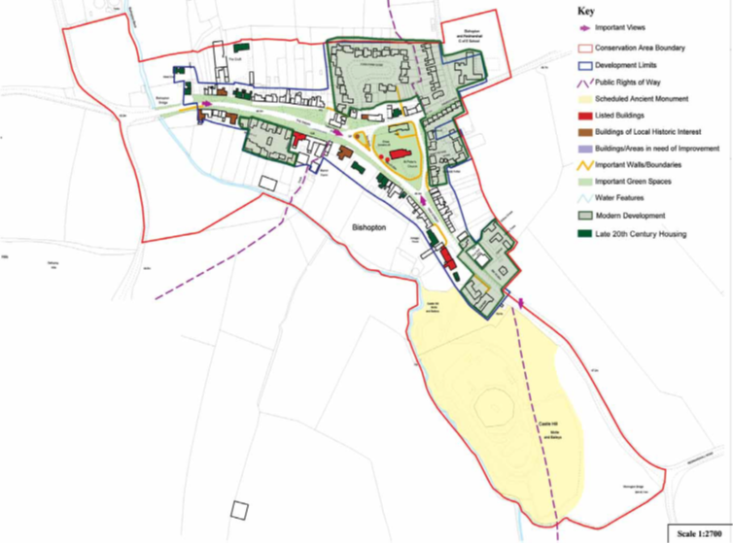
Figure 9 - Bishopton Conservation Area

The Bishopton Conservation Area (CA) will be surrounded by proposed solar PV and other infrastructure, such as fences, CCTV, batteries and invertors. The CA has important key recognised views both within and from outside the village. It is essentially a village set within an rural area.

Historic England (HE) in their representation in May 2024 (RR-207) states its concern for the Bishopton Conservation Area is specifically how the DCO application relates to the impact on setting of Bishopton Conservation Area. HE conclusions differ from the applicant’s conclusions. HE express concern relating to the stopping of footpaths and a change from a rural to an urban experience. They state that
“In conclusion of impacts at 8.10.60 we would suggest the magnitude of change should be low on the asset of medium significance resulting instead in a minor effect rather than a negligible one.”

The applicants own information states that “There are two Grade I listed buildings in the study area. These are referred to as the Church of St Cuthbert and the Church of St Andrew, Great Aycliffe. Within the Study Area, there are a total of 74 Grade II listed buildings. These are mainly centred in the villages of Coatham Mundeville, Aycliffe, Ketton, Great Stainton, Sadberge, Bishopton, Stillington, Thorpe Thewles, Redmarshall, and Carlton. Sadberge, Bishopton, Coatham Mundeville, and Aycliffe also have Conservation Areas”.(ES Appendix 8.3 APP-147).

This refers to the Geophysical study area but is relevant to the proposal and settings of all historic assets.

The DBC Landscape and Visual Amenity is an important report. It shows how the Solar Panels and related infrastructure would surround the Conservation Area, ( and Motte and Bailey) and significantly affect important views into and out of the village. BVAG therefore strongly disagree therefore with the conclusion of DBC LIR which in summary is that the application appropriately assesses the impacts of the proposed development on designated and non-designated heritage assets. The DBC LVA report states,

“Harm is identified to the Bishopton Conservation Area but is considered to be ‘less than significant’ and at the ‘lower end of the scale of harm’. “

The DBC LIR concludes that the proposal has the

“potential to comply with the requirements of DLP Policy ENV1’.

The proposal moves from ‘potentially’ compliant to compliant if the public benefits outweigh the harm. BVAG consider that the harm is greater than the applicant suggests, and the public benefit of the proposals are over played. Therefore BVAG do not consider that the proposal meets with the Local Plan ENV1 ` Protecting, Enhancing and Promoting Darlington’s Historic Environment.`

The Applicant’s own ES Appendix 8.2 ‘Historic Environment Settings Assessment’ in reference to Bishopton Conservation Area entitled “Contribution of Setting to Significance”
6.7.11 The setting of the conservation area makes a positive contribution to its significance. This is particularly true with the view from the south when moving along High Street, past the
scheduled motte and bailey, and into the boundary of the conservation area. This view
allows for the appreciation of the relationship between the motte and the settlement and
adds to the understanding of how power and influence would have been exerted over the
landscape.

It continues,
6.7.12 Similarly, when looking from Church View/Mill Lane to the south-west towards the motte and bailey allows for the best appreciation and understanding of the relationship between the modern and historic elements of the settlement are visible in the same view with the rural landscape in between.” (Document APP-146)

BVAG’s opinion is that intervisibility and setting of the village in such close proximity to the Panel Areas (particularly Panel Area F in the case of Bishopton) will have a profoundly negative impact on the village and the Conservation Area. This effect will be upon the heritage, and the resulting impact on people´s health and well-being, and sense of place and identity which results from that.

The applicant has taken a narrow view of heritage and removed it from its wider functions. Process of assessment has led to each heritage component and phase being reduced to its lowest possible denominator without taking account of the whole. The result has been a reduction in an understanding of the impacts. The assumption of a 40 year operational phase is also under question.

DBC’s ‘Local Impact Report - Landscape and Visual Amenity’ report clearly shows the proximity of the proposed Panel Area (page 42). The report demonstrates the intervisibility, imposition and industrial infrastructure from within and without the village, also from entering and leaving the village, where the juxtaposition of heritage buildings and unattractive industrial landscapes will reduce significantly the heritage value as it is experienced by residents and visitors alike.

The main mitigation measures to protect the Conservation Area are through screening by hedging and reduction on the Solar PV from 4.5m to 3.5m. The BVAG LVIA Report (part of the WR) concludes why vegetative screening is considered an uncertain and prolonged method of mitigation. The applicant’s reliance on vegetation to screen views in the longer term is not considered sufficient. There is no guarantee that it will remain in place, and in the case of new planting, becomes established as intended.

The reduction in PV heights from the ‘maximum proposed’ panel height from 4.35m to 3.5m is presented by the applicant as a mitigation. Commercial solar PV is unlikely to be as high as 4.35 and most commercial models are usually between 2.8 and 3.5m. What seems a concession was bringing the proposal back to industry norms. In fact the Proposed Development states the design concept is ‘ Limiting the height of the solar PV modules to 3.5m in height;’ still has significant implications for visibility. It is unclear if this is the final design proposal.

There is also an inherent contradiction that measures to mitigate visibility of the solar panels and other energy infrastructure - such as tall hedging - can then have an adverse effect on the landscape and traditional hedgerow patterns which exist. This view is shared in DBC’s LIR where they state,
“It is accepted that high hedging (on both sides of a footpath corridor) may be a preferable solution to views of solar panels, but it does not mean that this solution is acceptable in landscapes where such features are uncommon.” DBC LIR Para 5.6.12

The impact of the proposal on the 12th Century Bishopton Motte and Bailey.

The harm in this case would two fold. Firstly, the impact on views from and to the Castle and the erosion of shared landscape characteristics between the village of Bishopton and the Motte and Bailey, as well as how an observer would experience the setting of the Castle. The second is the exclusion from the applicant’s key archaeological surveys.

The Applicant recognises the importance of the asset in Para 8.10.67

“The asset draws significance from its setting primarily through its strategic location adjacent to Bishopton Beck and from its historic and spatial relationship with the settlement at Bishopton”.

It continues in Para 8.10.69

“The surrounding landscape does make a contribution to the significance of the asset through an ability to appreciate and understand further the power and influence asserted by the motte and its inhabitants over the wider area.”

It is therefore hard for BVAG to agree with the applicant that,

“The Proposed Development will lead to a Negligible magnitude of change on the asset which is of High heritage significance resulting in a Negligible Effect, which is not Significant for the purposes of EIA.”

The responses to the ExQ1 would be welcomed in explaining the conclusions reached.

With constantly developing interpretation of the events of the period in question, it would have been helpful in the ES Chapter 8 if the historic narrative could have been referenced and sources given. The Chapter does not reveal either the heritage author and is not referenced. For example, the period of Saxon history in the applicant’s Ch.8 makes no reference to the Danelaw which saw area around Bishopton as a border between the neighbouring Saxon kingdoms and those areas subject to Danish rule. One local press report states in relation to Bishopton Castle,
“It is possible that the fort constructed by Roger de Conyers at Bishopton was built on the site of an earlier earthwork perhaps of Danish origin.”

Source: Remains of castle stand on a hill between Darlington and Stockton | The Northern Echo

Its presence as a border fort adds interest to understanding the ebbs and flows of Saxon kingdoms as they negotiated with the Danish invaders and moved toward the unified Saxon state that would become England. The mound was one of twenty in England selected to be investigated by the Round Mounds Project during 2015 and 2016, looking for possible pre-historic mounds that had been re-used as Norman mottes. It is considered to be in a rare, highly preserved state.

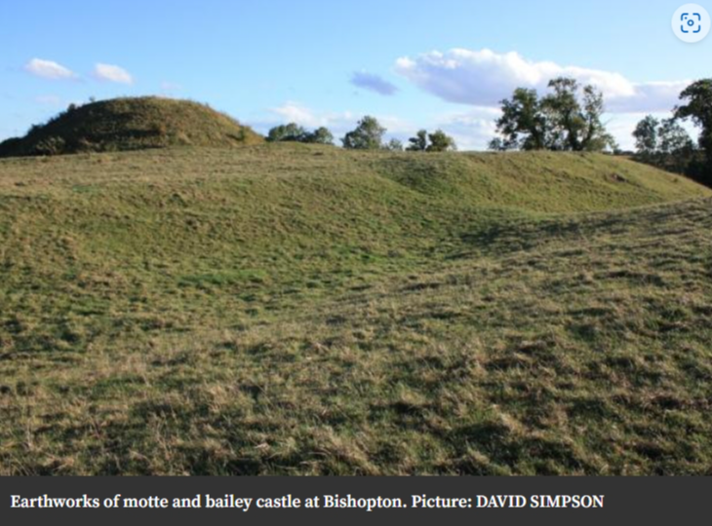
Figure 10 - Motte and Bailey on possible earlier fort

BVAG consider the Bishopton Conservation Area and the Bishopton Motte and Bailey a 12th Century scheduled Monument are of considerable importance both a heritage assets worthy of the public statutory protection, but as providing a sense of place and community to the residents, and visitors. Today such sense of place and identity is more important than ever.

Figure 11 - Bishopton - A heritage of centuries of farmed rural landscapes (CA Appraisal DBC).
Impact on Archaeology

BVAG are concerned about the loss of Archaeological material and potential damage to historical evidence of both local and regional, and potentially national importance. The DBC LIR refers to further recommended requirements in the Draft DCO Requirement 17 which BVAG supports.

It is unclear why the Bishopton Motte and Bailey and its surrounds were excluded from the area wide Geophysical survey – especially as this is the highest grade Heritage asset.
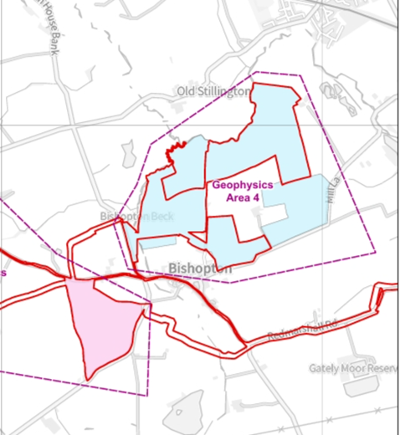
Figure 12 - Geophysical Survey Area 4 - excludes Bishopton Castle

As one of the area’s highest heritage assets it would seem important to include the Motte and Bailey and surrounds in the geophysical surveys. The plan above below indicates how the proposed cable runs immediately adjacent or even through the Motte and Bailey castle, so there is potential for harm through direct impact should cables be laid around and close to it.

RWE partly justify the exclusion of cable runs in Ch.8 of the ES

“As discussed previously, as there remains uncertainty as to the location of the cable routes for the Proposed Development….these have not been included within the geophysical survey remit so as to limit any potential impacts where construction will not eventually occur. Provision for further archaeological work on off-road cable routes if chosen, such as geophysical survey, are set out within ES Appendix 8.5: Archaeological Management Strategy (Document Reference 6.4.8.5).”

BVAG appreciate that with 30 plus km of potential cables, that geophysical surveys might be disproportionately unnecessary. But in the case of a small section adjacent to the Bishopton Scheduled Monument a short addition to the Area 4 Geophysical Survey would seem justified and proportionate. BVAG would request an explanation from the applicant and Durham County Council archaeologists if justified and acceptable.

Following the Geophysical Surveys areas were selected for trial trenching. The subsequent trial trenching excluded Panel Areas E and F entirely. It is not clear if this is driven by decisions around the Geophysical survey or if landowner consent and access was an issue due to crops in fields. Again, BVAG would request from the applicant and Durham County Council Archaeologists team if this is justified and acceptable, given Panel Areas E and F provide potentially rich sources of Archaeological finds.

The table below shows the areas selected for Trial Trenching which includes parts of Panel Areas A - D and exclude entirely E to F.

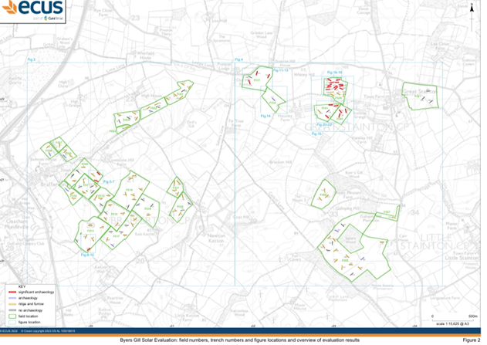
Figure 13 Trial trenching excludes Panel Areas E and F (APP-148)

BVAG note that the Applicants Document 6.4.8.4 ‘Environmental Statement - Appendix 8.4 Phase 1 Evaluation Trenching Report’ reveals an area rich in archaeology within the Order Limits. In its Executive Summary is states,

“The evaluation has clearly demonstrated that there are areas of archaeological importance and sensitivity within the development area that would require some form of mitigation should development work occur in those areas.”

The Archaeological record therefore shows an active area inhabited for centuries and millenia. It is worth noting the remarkably high level of finds. The report continues:
“One hundred and thirty-four trenches were excavated across 27 fields. Significant archaeology, probably dating from the prehistoric to the Roman period, was identified in 24 of the trenches within six of the fields, and is mostly of local importance but has the potential to be regionally important. More recent archaeology of lesser significance was recorded in 10 trenches across nine other fields. Ridge and furrow cultivation of mostly post-medieval but possibly medieval date was identified in 96 of the trenches, while 28 trenches contained archaeological features or deposits. “

BVAG agree with the applicant in their assessment that makes clear,
“The significance of the asset is primarily derived from its archaeological interest through the information excavation could yield in relation to its construction, occupation and abandonment. This archaeological interest is elevated as there is little other evidence from documentary sources. This information gained from any excavations would contribute to regional, and national, research into the administration of the north-east of England during the medieval period.”
(Ch.8 ES Para 8.10.65 Document APP-031)

The solar energy proposal will have a potentially significant harmful effect on the Bishopton Motte and Bailey, a Scheduled Monument, and an asset of the highest significance, and its setting. The Bishopton Conservation Area is important to the community and recognises the qualities and character of the buildings and the village within its rural setting. The applicants assessment has not adequately identified the impacts. The DBC LIR has identified harm, and asked the ExA to weigh this harm against public benefit. Bearing this in mind It is unclear why the Castle and surrounding fields were excluded from all Geophysical surveys and subsequent Trial Trenching despite these surveys being conducted on land immediately adjacent.

The remaining issues at this stage are dealt with through the issues framework table attached. BVAG reserves the right to comment further on the responses to ExQ1 and notes the Deadline 3 for comments on responses to ExQ1 (19 Sept 2024).

Appendix A

BVAG Issues Framework Table

https://www.forbes.com/companies/rwe-group/
https://www.rwe.com/en/investor-relations/rwe-share/share-at-a-glance/shareholder-structure/

